Usage of AD04M, LROCM and LRICM as shown in this image:

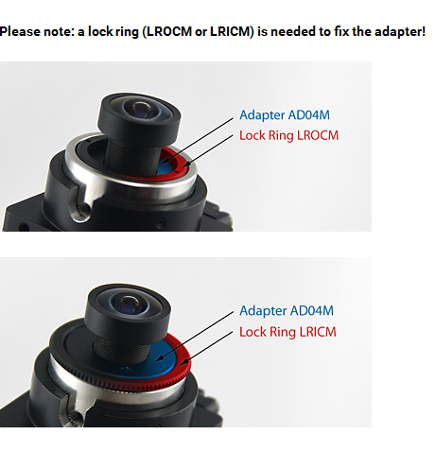

Usage of LRM12V2 as fixation of lens in adapter AD04M as shown in this image (a different adapter is shown there, but the principle is the same :

